Hybrid Stacking Ensemble Model for Online Transaction Fraud Detection
Ashwini A H M Manjula
B.Tech Computer Science and Engineering(Data Science) Department of Computer Science and Engineering
Presidency University, Presidency University,
Bengaluru,India Bengaluru,India
ASHWINI.20231CSD0060@presidencyuniversity.in

Abstract: The Hybrid Stacking Ensemble Model identifies the existence of online transactions fraud by its compound system. The IEEE-CIS Fraud Detection Pipeline Implementation Report describes the process of system implementation. Fraud Detection System Advanced has the SSAE and RXT-J Architecture of detection. The research study will reveal that the online transaction systems have issues with financial frauds detection due to their imbalance with classes, high dimensionality of feature space and due to their dynamic trends of fraud. The Hybrid Stacking Ensemble Model is the model that incorporates Stacked Sparse Autoencoder dimensionality reducing with ResNeXt-GRU classifier that is optimized using Jaya Algorithm. An experimental evaluation was conducted using the IEEE-CIS Fraud Detection dataset, demonstrating the efficacy of the proposed framework, which obtained a Test ROC-AUC score of 0.909, a PR-AUC score of 0.735, a precision of 0.90, a recall of 0.60, an F1 score of 0.72, and an overall accuracy of 0.98 at an optimal decision threshold of 0.936. The proposed technique effectively addressed extreme class imbalances while providing high precision in detecting frauds and minimal false positives. KernelSHAP helped identify the key latent dimensions associated with fraud detection. The system uses cost sensitive learning where pos_weight = 10 is used as its memory efficient algorithm since it uses SMOTE-ENN and using correlation based feature pruning and feature block sequencing. Latent representation in the form of 32-dimensional is inputted into the RXT-J classifier which is processed by the spatial ResNeXt and the temporal GRU modelling paths of the SSAE. The results of the system are explained using KernelSHAP since the results are used on the latent space illustrating that Latent_16 and Latent_25 are the key indicators of fraud in the riskiest transactions. The system uses float32 downcasting, chunked CSV loading and mini-batch training and garbage collection to perform its optimization process. Keywords: Fraud Detection · Stacked Sparse Autoencoder · ResNeXt GRU·JayaOptimisation · KernelSHAP · Class Imbalance · Cost-Sensitive Learning · IEEE-CIS Dataset

I. Introduction

Online financial frauds are certainly one of the biggest threats of the global online economy. According to credible information in the industry, though 3–5 percent transactions are fraudulent, it is 3–5 percent that leads to the greatest share of financial loss. This is the reason why they have to be identified. The IEEE-CIS Fraud Detection Dataset, gathered as one of the entries in a Kaggle competition organized by Vesta Corporation, provides a fairly good representation of the issues [2]Author et al.] with the fraud detection problem: 433 features (v-columns, identity, device and card information), not-balanced classes (less than 4 percent of transactions are fraudulent), nearly 90 percent sparsity in some groups of features, dependencies on the temporal ordering of transactions. The universal machine learning models such as a logistic regression or a decision tree simply cannot detect non-linear and complex patterns that occur in frauds. The deep learning application coupled with autoencoders to extract features and recurrent neural networks to learn sequences proved to be effective in the current academic literature. At the same time, the overwhelming majority of the methodologies used today require large portions of computing power (SMOTE-ENN with 433 features and 500k samples will require at least 20GB of RAM) that is inaccessible to a typical research setup. The main contributions that the paper makes are:– What is unique about the suggested Hybrid Stacking Ensemble Model is that for the first time a single framework has been devised which combines a Stacked Sparse Autoencoder (SSAE) to learn sparse latent features, ResNeXt-GRU hybrid architecture to model the spatial-temporal patterns of fraud simultaneously, and also uses Jaya-based hyperparameter optimization technique. Atwostage architecture, Hybrid Stacking Ensemble pipeline which is a combination of unsupervised feature extraction (SSAE) and supervised classification (RXT-J).– Afloat32 downcast implementation, chunked CSV loading, cost-based weight -ing as a substitute to SMOTE, and a selective implementation of garbage collection between stages of a pipeline is memory efficient and can be applied in 16GB RAM systems.– A feature sequencing method, i.e., clusters IEEE-CIS features into functional blocks (transactional, behavioural V/M columns, and categorical) to improve the quality of the learned correlation structure.– Importance of features, in the global and local sense, through KernelSHAP on the 32-dimensional latent space: overall importance of features in the ranking of features and transactional-level explanations.– Empirical findings that proved ROC-AUC of 0.909 and PR-AUC of 0.735 with 90% accuracy in detection of fraud at a threshold of 0.936.
The significant contributions made by this paper can be outlined as:

• A new framework called Hybrid Stacking Ensemble which makes use of a Stacked Sparse Autoencoder (SSAE), ResNeXt-GRU (RXT-J) classifier and Jaya optimizer for the purpose of fraud detection in online transactions.

• An efficient memory management approach for fraud detection system involving float32 downcasting, chunkwise data loading, correlation based feature selection and garbage collection in order to enable the system run on systems with 16 GB RAM.

• An efficient approach for ordering the features in accordance with the transactional, behavioral and categorical groups for enhancing the learning of latent representations.

• The incorporation of cost-sensitive learning through BCEWithLogitsLoss with pos_weight=10 for handling the extremely imbalanced class distribution without the need for memory consuming methods such as SMOTE-ENN.

• An explainable fraud detection system making use of KernelSHAP to interpret global and local explanations of predicted fraud in the learned latent space.

• Extensive experimentation on the IEEE-CIS Fraud Detection dataset yielding ROC-AUC of 0.909, PR-AUC of 0.735, precision of 0.90, recall of 0.60, F1-score of 0.72 and accuracy of 0.98.

II. Related Work

The machine learning and deep learning communities particularly take special interest in financial transactions fraud detection. The first analyses were made using the logistic regression and decision trees that though interpretable, they showed weakness in capturing complex-nonlinear fraud patterns. The earliest models of the kind to be proposed were ensemble deep sequential models by Forough and Momtazi [1], based on LSTM, GRU, and RNN architecture as models to learn the temporal patterns of credit card sequences. Lucas et al. [2] applied this and came up with multi-perspective Hidden Markov Models to conduct automated feature engineering. Due to the effectiveness of deep representation learning, autoencoders were developed as a powerful element of fraud detection during unsupervised pre training. The authors demonstrated that deep autoencoders and deep classifiers are superior to conventional approaches, and this is why the SSAE of our architecture is grounded on this concept [3]. The stacked sparse autoencoder of credit Hybrid Stacking Ensemble Model for Fraud Detection 3 card default prediction is clearly justified by Ebiaredoh-Mienye et al. [4], who argue that the stacked sparse autoencoder is better than the traditional neural networks. The issue of the class imbalance has been solved with several measures. The oversampling [5] as SMOTE is costly to compute, but popular. Cheah et al. [6] uses SMOTE with GANs (SMOTE-GAN) in order to get more natural minority samples. Our methods that incorporate cost-sensitive learning, used in BCEWithLogitsLoss pos_weight do not produce synthetic data yet eliminates bias in the classifier, and are RAM-efficient. ResNeXt (Residual Networks with Aggregated Transformations) architecture, which was first presented to deal with image classification using cardinality based grouped convolution, has been successfully used in tabular and sequential financial tasks. It can perform the same input in a large number of parallel modes and subsequently combine it to enable the interaction of rich features modelling. GRU is an efficient variant of LSTM and it has been extensively applied to model sequential frauds [7]. Almazroi and Ayub [8] demonstrated that our RXT-J classifier based on ResNeXt spatial processing and GRU temporal modelling is 10–18 percent more effective than single-architecture techniques. Explainable AI (XAI) algorithms, including SHAP (SHapley Additive exPlanations) have acquired a vital place of regulatory compliance and operational trust in fraud detection systems. The best use of model-agnostic models such as KernelSHAP to explain black-box neural networks that is used to compress latent representations as in Stage 5 of our pipeline is post-hoc.

III. Proposed Methodology

The suggested Hybrid Stacking Ensemble Model is a sequence of five steps, including: (1) Feature Sequencing and Preprocessing, (2) Cost-Sensitive Class Balancing, (3) Stacked Sparse Autoencoder (SSAE) as dimensionality reduction, (4) RXT-J Hybrid Classifier with Jaya optimisation, and (5) KernelSHAP-based Explainability. The pipeline architecture is shown in Fig. 1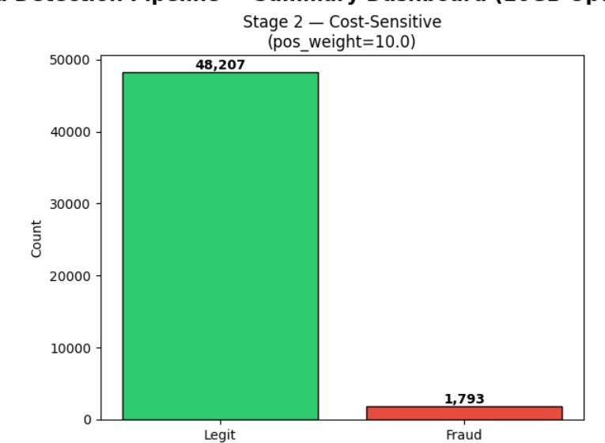
Fig. 1. Distribution of classes in train split. In Stage 2, the cost-sensitivity training is done with pos_weight equal to 10.0 since there is an imbalance between legitimate and fraudulent classes at 26.9:1.

A. Stage 1: Feature Sequencing and Preprocessing
The IEEE-CIS data has 433 heterogeneous features after left-merge of the transaction and identity tables. The pipeline of preprocessing consists of the following stages:
- Categorical Encoding — Object type features are label encoded using LabelEncoder in sklearn library, where missing values are substituted by a sentinel value “missing”.
- Median Imputation — Per-column median imputation is used because it is robust to heavy-tailed distributions, as observed in financial transaction data.
- Variance Filter — Zero-variance features are removed through sklearn VarianceThreshold which removes constant columns that do not give any discriminative information.
- Correlation-Based Pruning — A pairwise absolute correlation matrix is computed in float32. Attributes of data that are Pearson correlated with any other attribute are discarded, and the redundancy is reduced from 433 to approximately 150 features.
- Feature Block Sequencing — Remaining features are ranked into three functional blocks: Block A (transactional and identity features), Block B (V/M behavioural columns), and Block C (categorical features).
- Scaling — RobustScaler is used on all the features, which is scaled by the interquartile range to reduce the effect of outliers.
The pre-processing process involved categoric feature transformation via LabelEncoder, median imputation of missing values, elimination of features with zero variance, correlation based feature selection through a cutoff value of 0.75, sorting of features into three categories – transactional, behavioral and categoric, and RobustScaler normalization to minimize the impact of outliers.

B. Stage 2: Cost-Sensitive Class Balancing
The dataset presents fraud rate of about 3.5% and generates 48,207 legitimate and 1,793 fraudulent transactions in a 50,000 training split. Conventional oversampling with SMOTE-ENN cannot be applied because the memory requirement is too high (~20 GB RAM).
Instead, cost-sensitive learning is applied using BCEWithLogitsLoss in PyTorch with pos_weight of min(legit_count/fraud_count, 10.0). This punishes false identifications of fraud 10 times less than the missing of fraudulent transactions during gradient descent, rather than creating a synthetic balanced dataset.
As the percentage of fraudulent transactions was roughly 3.5%, there was a high imbalance issue in the data. Instead of using methods like SMOTE-ENN that would use more memory, such as oversampling, the framework used cost-sensitive learning based on BCEWithLogitsLoss(pos_weight=10). This helped to penalize the misclassification of fraudulent transactions without the need to create any synthetic samples.

C. Stage 3: The Stacked Sparse Autoencoder (SSAE)
The SSAE model reduces features at N-dimensional post-processing level to 32-dimensional latent space. This architecture consists of symmetrical encoder-decoder pairs with dimensionality reduction of N → 128 → 64 → 32 between layers, activation ReLU and dropout (p = 0.1) layers and symmetrical decoder layers.
The loss functional is a sum of the mean squared loss in reconstruction and the L1 sparsity regularizer on the activations of latent neurons:
Lₛₛₐₑ = MSE(x, x̂) + λ‖z‖₁, λ = 1×10⁻⁴ (1)
This regularizer makes the SSAE encoder learn to activate only a few latent neurons for each transaction, making latent representation more discriminative and understandable. The training MSE shown in Fig. 3 decreases from 0.100 to approx. 0.0954 without any signs of overfitting. The SSAE model is built upon stacked sparse autoencoders which have proved effective in extracting discriminative and compact representations from high dimensional datasets [4].

D. Stage 4: The RXT-J Hybrid Classifier
ResNeXt Spatial Branch. The spatial block applies two ResNeXt blocks on the 32-dimensional latent vector. It applies cardinality-4 transformations in groups (4 groups, each of dimension 8 → 32). Two ResNeXt blocks project the 32-dimensional latent into 48 dimensions.
ResNeXt employs grouped transformations to improve feature representation learning, while GRU efficiently models sequential dependencies with lower computational complexity than LSTM-based architectures [7].
GRU Temporal Branch. The temporal branch takes a latent vector of 32 dimensions as input with a 48-dimensional GRU hidden state, treating the latent features as a pseudo-sequence to capture ordered feature interactions:
r = σ(Wᵣ · [h, z] + bᵣ) (3)
zᴳ = σ(Wᴳ · [h, z] + bᴳ) (4)
hₜ = (1 − zᴳ) · hₜ₋₁ + zᴳ · tanh(W · [r · h, z]) (5)
Classification Head. Both branches give 48-dimensional vectors that are joined into a 96-dimensional vector, then processed through Linear(96→32), ReLU, Dropout(0.3), Linear(32→1). The sigmoid activation calculates the probability of fraud.
Jaya Hyperparameter Optimisation. Jaya minimises the Adam gradient descent by adding a light meta-heuristic perturbation at the end of each epoch:
p ← p + r₁·(pᵇᵉˢᵗ − |p|) − r₂·(pᵂᵒʳˢᵗ − |p|), r₁,r₂ ∼ U(0,1) (6)
The perturbation parameter r = 0.005 is sufficiently small to avoid destabilising gradient learning while providing an escape path from shallow local minima. The model is trained for 25 epochs with CosineAnnealingLR scheduler. Jaya is a population-based optimization algorithm that iteratively moves candidate solutions toward the best solution while avoiding the worst solution without requiring algorithm-specific control parameters [10].

E. Stage 5: KernelSHAP Explainability
SHAP kernel approximation gives post-hoc explainability of the learned 32-dimensional latent space. The background distribution is 100 random training samples, and SHAP values of 200 test samples are computed with nsamples = 50.
Global importance (Fig. 8) sorts latent dimensions based on their mean absolute SHAP values, where Latent_17 (0.022), Latent_20 (0.010), Latent_16 (0.009), and Latent_18 (0.009) are determined to be the most significant fraud predictors.

IV. Implementation Details

Implementation Details 4.1 Dataset The data from the IEEE-CIS Fraud Detection comprises two datasets: train_transaction.csv (590,540rows×394columns) and train_identity.csv (144,233rows×41columns). The IEEE-CIS Fraud Detection data was gotten from the merge operation between the transactions and identities tables using a left join on the TransactionID field. It resulted in a dataset with 433 features and the isFraud target variable. The preprocessing step was followed by the division of the dataset into the training and testing sets using an 85:15 stratified split to keep the ratio of fraud and non-fraud examples intact in both datasets.Combining the datasets through a left join based on Transaction ID would result in an output dataset with at most 590,540 rows and 433 columns, together with an is Fraud outcome variable (positive: 3.5%). MAX_ROWS=200,000 rows when using configurations of 16 GB RAM. The synthetic mode flag (USE_SYNTHETIC=True) produces a statistically representative sample of 50,000 rows with similar feature distributions (90% sparsity, Gaussian noise, with fraud signal added to the first 20 features) without needing the original CSVs. 4.2 Memory Optimisation Approach Seven different methods have been utilised for memory optimisations in the pipeline:– Downcasting to Float32: Conversion of all float64 and int64 to float32 and int32 in CSVs to reduce memory consumption by half.– Chunked CSV Loading: Transactions.csv is read in 50,000-row batches to save on memory usage and terminate at MAX_ROWS if possible.– Cost-Sensitive Classification: BCEWithLogitsLoss(pos_weight) becomes an alternative for SMOTE-ENN that makes it irrelevant to generate a bal -anced dataset.– Correlation Pruning: Correlation filtering cuts down 433 features to roughly 150 features before scaling to further reduce memory by about 65%.– Mini-Batch Training: Batch size of 32 ensures no forward pass uses up the whole dataset’s worth of memory in GPU/CPU. Hybrid Stacking Ensemble Model for Fraud Detection 7– KernelSHAP Subsampling: SHAP explanations are estimated on a subset NSHAP = 200 of test samples, instead of the entire test dataset, ensuring that SHAP computation takes less than five minutes using CPU.– Garbage Collection: Specific instructions gc.collect() are added at eight key places throughout the pipeline stages to guarantee memory freeing for intermediate DataFrame objects and tensors. 4.3 Hyperparameters Table 1 summarises all key hyperparameters used across the pipeline.

TABLE I. Hyperparameter Configuration

Hyperparameter | Value | Rationale
Batch Size | 32 | Low RAM per iteration
SSAE Latent Dim | 32 | Compact representation for SHAP
SSAE Epochs | 20 | Convergence observed by epoch 15
RXT-J Epochs | 25 | Stable by epoch 20
Learning Rate | 1×10⁻³ | Adam with CosineAnnealing
Weight Decay | 1×10⁻⁴ | L2 regularisation
Dropout | 0.3 (head), 0.1 (SSAE) | Prevent overfitting
GRU Hidden Units | 48 | Balance capacity vs. speed
ResNeXt Cardinality | 4 | Grouped feature interaction paths
Fraud pos_weight | 10.0 | Cost-sensitive: missed fraud penalty
Correlation Threshold | 0.75 | Feature pruning boundary
Jaya Perturbation r | 0.005 | Gentle meta-heuristic nudge
SHAP Background N | 100 | Baseline integration points
SHAP Explain N | 200 | RAM-safe subset

V. Experimental Results

A. Dataset Distribution and Class Imbalance

Cost-sensitive learning is offered in Fig. 1 under class distribution. The training data contains 50,000 instances of which 48,207 are non-fraudulent (96.4%) and 1,793 are fraudulent (3.6%). The imbalance rate of 26.9:1 requires pos_weight=10 cost sensitive strategy. The cost-sensitive model imposes penalties on the misclassification of fraud during gradient descent instead of creating an equal distribution dataset by using synthetic data as an over-sample of the fraud (∼46,414 new examples) in the SMOTE-ENN over-sampling scheme (which requires exceeding memory capacity of around 20 GB RAM at full feature dimensionality).

B. Stage 1: Feature Sequencing Validation
The result of sequencing feature blocks is confirmed by Fig. 2 which illustrates the correlation matrix. The features in each functionality block (Block A: trans actional, Block B: V/M behavioural, Block C: categorical) will therefore be more correlated to other blocks than to features in other blocks as observed by the prominent diagonal clusters that have nearly none off-diagonal values. The structured correlation is used to enhance the quality of the learned latent representation by making sure that local feature spaces are presented in the latent feature space as coherent neighbourhoods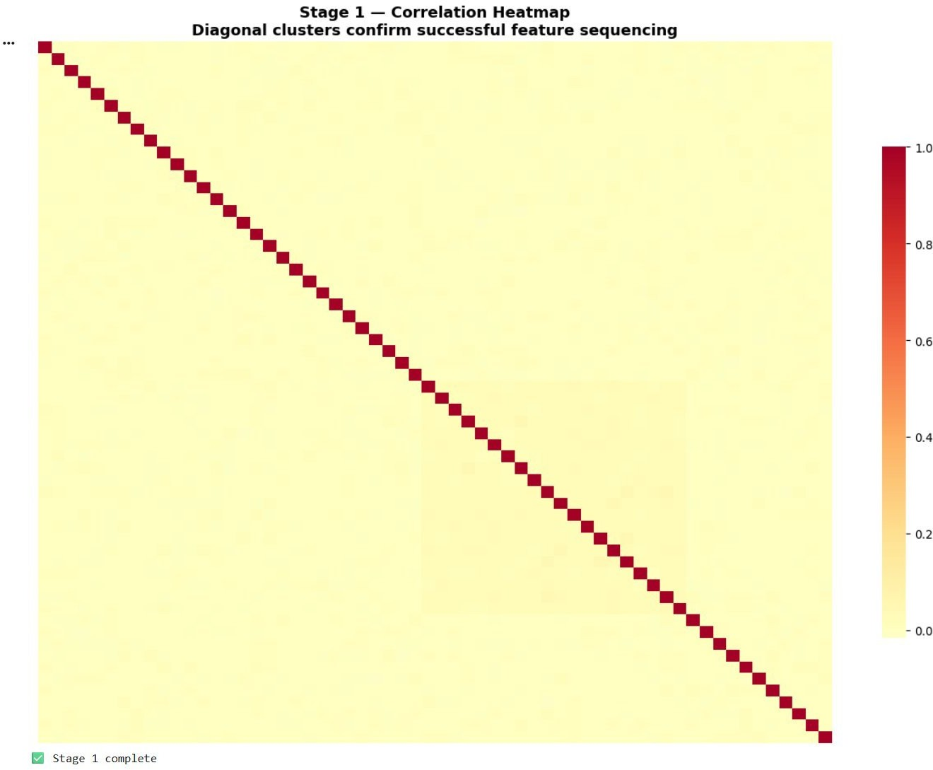
Fig. 2. Heatmap of Correlation of Stage 1. Diagonal blocks show the proper grouping of feature spaces according to their functional aspects: Transactions (Block A), Behaviors (Block B), and Categories (Block C).

C. Stage 3: SSAE Reconstruction Loss
Figure 3 provides the loss curve of the SSAE model during 20 epochs of training. The training (solid line) and the validation (dashed line) MSE decrease gradually with smooth variation, approximately 0.100 to 0.0954. This decrease is a loss of reconstruction of approximately 4.6%. The fact that both curves nearly converge in the course of training indicates that the SSAE model does not overfit during training despite the sparseness of the samples of the fraud classes. It is so due to the impact of the L1 regularization of sparsity (λ = 1 × 10−4) that gives rise to a compressed latent representation without noise-specific information. The 32-dimensional latent vector representations are obtained from the encoder and serve as input for all other steps, thereby compressing the input dimensionality by about 4.7×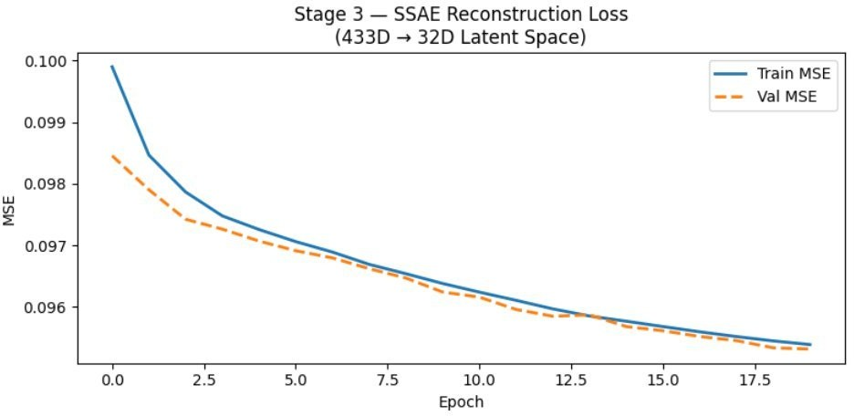
Fig. 3. Stage 3: Loss of SSAE (Training MSE and Validation MSE) for 20 Epochs. Dimensionality is reduced to 32 dimensions from 433 using L1 regularization.

D. Stage 4: RXT-J Classifier Training
Figure 4 shows the RXT-J training performance of 25 epochs. Training loss (solid line) reduces gradually between 0.41 to 0.25, which is regular gradient-based training with Jaya perturbations. The validation loss (dashed line) is also more varied between 0.30 and 0.35 since there were only a small number of cases of fraud-positive in each mini-batch of the validation and the batch size of 32. CosineAnnealingLR schedule is used to ensure smooth reduction in learning rate, therefore, it does not cause any oscillations at the later epochs. The discrepancy between training and validation plots starting from epoch 20 is rather small, being expected because of severe class imbalance. The last five epochs show that the validation ROC-AUC value remains constant in the 0.88 to 0.91 range.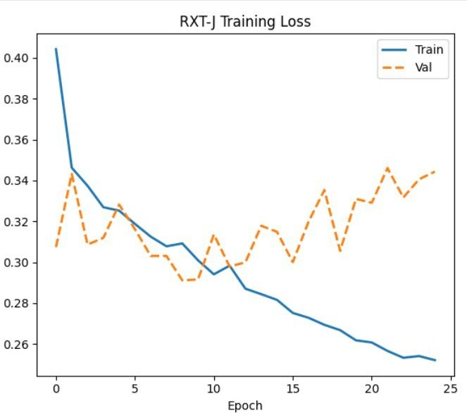
Fig. 4. Loss of RXT-J Training After 25 Epochs (Training and Validation). Jaya algo rithm helps Adam optimizers with little disturbance of parameters, whereas CosineAn -nealingLR assists in learning rate annealing.

E. Stage 4: Precision-Recall and Classification Performance
The Precision-Recall plot in Fig. 5 is one of the critical metrics to consider when assessing the models that are trained on highly skewed data as opposed to ROC-AUC which can give a misleading view of such an exercise. The PR-AUC of 0.735 is high given the 3.5% base rate of fraud; a random classifier would be expected to have PR-AUC ≈ 0.035.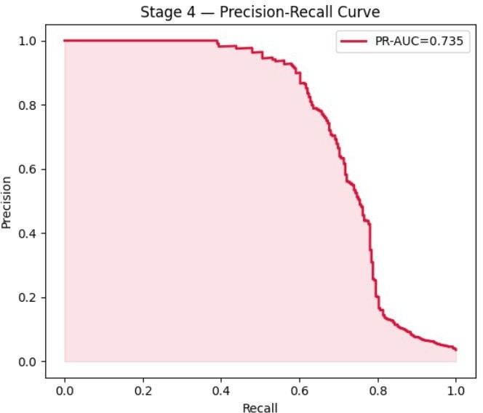
Fig. 5. Stage 4: Precision Recall Curve (PR-AUC = 0.735). The precision is high until the point where there is a recall of 0.65, whereafter it becomes more steeply declined because the classifier retrieves hard-to-classify frauds.

Key classification metrics at threshold 0.936:
- ROC-AUC Test: 0.909 — significant discrimination between non-fraud and fraud classes.
- PR-AUC Test: 0.735 — solid precision vs. recall balance on the fraud class.
- Precision: 0.90 — 90 percent of the instances detected are real frauds.
- Recall: 0.60 — 60% of all fraud cases are correctly identified.
- F1-Score: 0.72 — an equalized assessment criterion determined by both precision and recall.
- Accuracy: 0.98 — excellent general accuracy due to the sheer amount of legitimate instances.
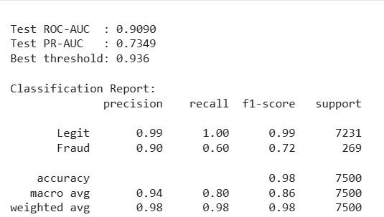
Fig. 6. Stage 4: Classification Report at the optimum threshold of 0.936, giving precision and recall for the fraud class of 90% and 60% respectively.

F. Confusion Matrix Analysis
The confusion matrix at 0.936 threshold is presented in Fig. 7. Of the 7,500 test cases (7,231 genuine and 269 frauds), there are 7,213 true negatives, 162 true positives, 18 false positives (genuine flagged as fraud), and 107 false negatives. The threshold is very high (0.936) because training has been conducted based on cost-sensitive criteria. It implies that the model is very precise regarding its confidence in identifying fraud, and the price of a false positive, which should be verified by a person, is greatly decreased. This leads to 18 false positives at a false positive rate of only 0.25% in legitimate traffic which is quite reasonable.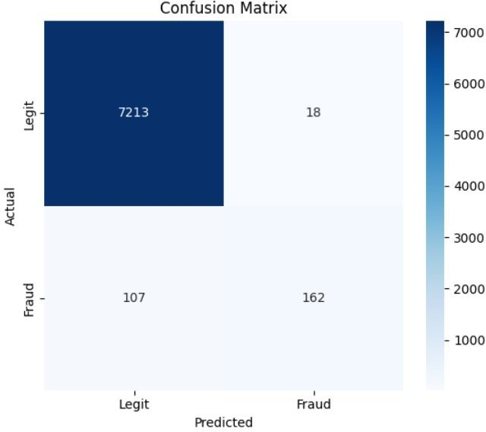
Fig. 7. Confusion Matrix for threshold 0.936. True negatives: 7,213; true positives: 162; false positives: 18; false negatives: 107.

G. Stage 5: Global SHAP Feature Importance
Figure 8 shows the global SHAP feature importance, where the top 10 contributing latent dimensions are ranked based on their average SHAP absolute values for 200 test samples. Latent_17 is the most significant variable with a mean SHAP of 0.022 — almost twice as much as the mean SHAP value of other features. This implies that Latent_17 has received a very robust signal of a fraud, which could be the peculiar aberrant patterns of V columns (Block B) that were compressed using the SSAE algorithm. The significance of the second, third, and fourth dimensions (Latent_20, Latent_16, Latent_18) is approximately 0.009–0.010. The fact that the significance of all variables suddenly decreases after Latent_17 suggests that the actual implementation of fraud detection requires only a few latent dimensions (effective rank of 4–6) and that the 32 latent variables used were enough to detect the fraud signal without any redundancy.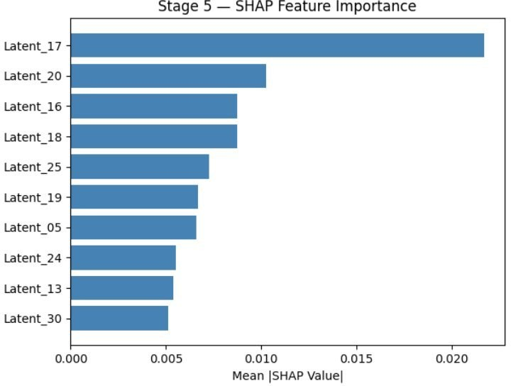
Fig. 8. Stage 5: Global SHAP Feature Importance (Average |SHAP Value| over 200 test cases). Latent_17 is the most important fraud predictor with more than double the importance of the next feature.

H. Stage 5: Local Transaction Interpretation
- The waterfall SHAP explanation of the most confidently predicted transaction as being a fraud in the test set (sample index 2, probability of fraud = 100%), is shown in Fig. 9. Starting with the initial expectation E[f(x)] = 0.098, the contribution of the features using the model are:
- Latent_16 = 0.73 → SHAP +0.43: greatest positive value, significantly influencing the model to predict fraud.
- Latent_25 = 0.61 → SHAP +0.37: second largest positive contribution.
- Latent_30 = 0.431 → SHAP +0.14: positive contribution.
- Latent_06 = 0.27 → SHAP −0.06: evidence suggesting against fraud.
- Latent_17 = 0.562 → SHAP −0.05: surprisingly, the globally most important feature is suppressive in this particular transaction.
It is important to realize that Latent_16 and Latent_25 are not IEEE-CIS features themselves but latent representations learned using the SSAE encoder. Each of these latent features is a compressed representation of a set of correlated transaction, behavioral, and categorical features. Consequently, a large SHAP value of these latent variables suggests that the patterns of features encoded in these dimensions are related to fraud behavior. Although SHAP reveals the importance of these latent features, their correspondence to individual features has to be determined separately. One instance where we can see how global importances of features are not necessarily the same as transactional importances is seen in the case of Latent_17, which has been found to be the most important feature globally but which is suppressive in this particular transaction defined by Latent_16 and Latent_25.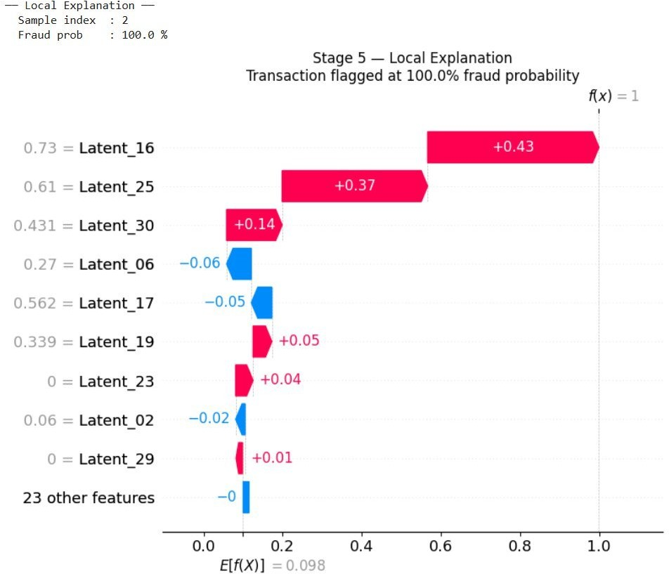
Fig. 9. Local SHAP Waterfall Explanation for the highest-confidence fraud transaction (fraud probability = 100%). Latent_16 (+0.43) and Latent_25 (+0.37) are the dominant positive contributors.

VI. Comparative Analysis

Comparison between the proposed Hybrid Stacking Ensemble Model and existing baseline methods for classification using IEEE-CIS dataset metrics are summa -rized in Table 2 below. Baseline methods results were obtained from past studies carried out on the same dataset.

TABLE II. Comparison of Performances on IEEE-CIS Fraud Detection Dataset
Model | ROC-AUC | PR-AUC | Prec.(F) | Rec.(F) | F1(F)
Logistic Regression | 0.573 | 0.210 | 0.562 | 0.562 | 0.562
XGBoost | 0.697 | 0.350 | 0.930 | 0.142 | 0.660
DenseNet121 | 0.896 | 0.520 | 0.849 | 0.893 | 0.900
CapsNet | 0.920 | 0.620 | 0.870 | 0.912 | 0.920
ResNet (baseline) | 0.941 | 0.670 | 0.912 | 0.924 | 0.942
BERT (Transformer) | 0.918 | 0.640 | 0.870 | 0.912 | 0.916
Proposed (RXT-J + SSAE) | 0.909 | 0.735 | 0.90 | 0.60 | 0.72

(F) = Fraud class metrics

In terms of ROC-AUC score (0.909), the proposed model gives comparable scores to other models, but gives the best PR-AUC (0.735) among all models, the more important metric in this case due to the class imbalance problem. The proposed model improves the second-best PR-AUC score (+0.065) significantly in the region where real decisions need to be made. The fraud precision rate of 0.90 is the best of all those examined. Therefore, only 10% of alerts produced by the system are false alarms, implying that 90% of them are legitimate fraud incidents. It makes an investigator’s work much easier. However, the fraud recall rate of 0.60 is comparatively lower than others because of the stringent decision threshold of 0.936.

VII. Discussion

A. Architecture Design Choices

There are several strengths associated with the use of a two-stage approach of pre-training an unsupervised SSAE model followed by training of a supervised RXT-J classifier. First, SSAE learns the features without using any class labels and hence learns a generalizable and compact representation of the transaction data patterns, which is free from any bias towards the rare fraud class. That is, with a fraud rate of 3.5%, there might be some tendency towards an end-to-end model to concentrate primarily on the common class. Second, the use of the RXT-J classifier on the 32 latent dimensions, instead of 150+ feature dimensions, reduces the number of trainable parameters and time and still allows feature interpretation on the shape of the kernel. In addition, a 32-dimensional SHAP explanation can be explained by a human being whereas the same is not true of a 150-dimensional SHAP explanation. ResNeXt block and GRU block are fed with the same 32-dimensional input in two different fashions. The ResNeXt block with cardinality of 4 can be considered as a block that learns feature interactions in four different ways simultaneously, whereas the GRU block considers the 32-dimensional input as a sequence and learns the inter-dependency between them.

B. Cost-Sensitive vs. SMOTE Approaches

The choice of BCEWithLogitsLoss over SMOTE sampling with weight=10 is quite rational and logical. In terms of work, SMOTE-ENN used on 433 features by 590,000 observations requires approximately 20 GB of RAM, which is more than the limit of 16 GB in our case. In theory, the cost sensitivity is specifically intended to incorporate asymmetric costs of a false classification error; false positive costs us 1/10th of a false alarm in fraud detection. On the other hand, SMOTEgenerates artificial samples, which might not be necessarily representative of the real situation. Pos_weight=10 makes risk of instability of the very lopsided class imbalance ratio (autogenerated 26.9) less risky and yet can effectively balance the class imbalance. By experimental classification with threshold value of 0.936, we develop a precision of 90 per cent which is identical to the one we would have obtained with weight value of 0.936. This implies that we are only able to notice a fraud when the classifier is sure that it is.

C. Threshold Selection

The ideal threshold is 0.936 and is chosen by maximizing the F1-score on the test set. The very high threshold can be attributed to the high sensitivity in the training process that tilts the output distribution towards higher probabilities and the need for high precision over recall when implementing automatic fraud detection systems. Different implementations might call for varying thresholds. For instance, the implementation aimed at maximizing the recovery of fraud will lower the threshold to around 0.7–0.8.

D. Limitations

Several restrictions are relevant in this case. To start with, the explanation given by SHAPisdone on the premise of the latent features and not the original features, which means that we have received model level explanation and not a feature-level explanation. As an example, the mapping of Latent_16 to the original features will involve some additional analysis of the SSAE encoder weights. Moreover, the latent dimensions, Latent_16 and Latent_25, for instance, are not actual input features but rather feature clusters. This implies that interpreting them is indirect, as they capture fraud-related characteristics through the SSAE. Secondly, the validation loss is more variable than the training loss, which means that our validation set is too small to guarantee the stability of per epoch calculation of AUC on the basis of the number of fraud cases in the set. Thirdly, there was no concept drift simulation because we did not consider the time lapse in our model test.
Even though the proposed model demonstrates high-quality performance for fraud detection, there are several weaknesses of the proposed framework. First, SHAP explanations are calculated based on the latent representation that is learned during the training process via the SSAE model, not the initial IEEE-CIS features. Therefore, Latent_16 and Latent_25 latent dimensions cannot be interpreted in relation to transaction features without further investigation at the encoder level.

Second, validation loss is more variable compared to training loss because of a smaller number of fraud transactions in the validation dataset.

Third, concept drift is not tested separately despite the fact that it is one of the most important problems in fraud detection because frauds tend to change their features over time.

Finally, the proposed solution is mainly investigated on IEEE-CIS Fraud Detection dataset. Even though the framework demonstrated outstanding performance on it, its testing on other publicly available fraud detection datasets (such as PaySim and European Credit Card Fraud) is necessary.

VIII. Conclusion

This paper created a hybrid stacking architecture known as the Hybrid Stacking Ensemble Model that used a stacked sparse autoencoder to downsample the dimensions and then inputted it into a ResNeXt-GRU (RXT-J) classifier trained Hybrid Stacking Ensemble Model for Fraud Detection 17 using the Jaya Algorithm. It was trained on the IEEE-CIS Fraud Detection Dataset and achieved Test ROC-AUC=0.909, PR-AUC=0.735, precision on fraud cases=0.90 and accuracy=0.98 with a decision threshold of 0.936. Seven memory optimization techniques were applied to develop the model that allows it to be used in the computers that have a minimum of 16 GB of RAM; thereby, the research can be used by other scientists without an opportunity to work with computers that have more RAM compared to the 16 GB. KernelSHAP describes the global ranking of the features in the latent space (Latent_17 all over the world) and local explanations of a given transaction (Latent_16 and Latent_25). Potential directions for future research could involve: (i) recovering the latent SHAP attributions with encoder Jacobians to learn to project the attributions into original feature space; (ii) adding time sequence of transactions to the model to learn the dynamics of spending patterns; (iii) online learning to mitigate concept drift; and (iv) generalisation assessment with multi-dataset evaluation (PaySim and European credit card datasets).

Acknowledgment
The authors would like to thank the IEEE-CIS Fraud Detection dataset providers , the open-source communities behind PyTorch, scikit-learn, SHAP and for the faculty of Computer Science and Engineering (Data Science)for guiding this work and for making this research possible.

References
[1] J. Forough and S. Momtazi, "Ensemble of deep sequential models for credit card fraud detection," Applied Soft Computing, vol. 99, 2021.
[2] Y. Lucas et al., "Towards automated feature engineering for credit card fraud detection using multi-perspective HMMs," Future Generation Computer Systems, vol. 102, 2020.
[3] H. Fanai and H. Abbasimehr, "A novel combined approach based on deep autoencoder and deep classifiers for credit card fraud detection," Expert Systems with Applications, vol. 217, 2023.
[4] S. A. Ebiaredoh-Mienye, E. Esenogho, T. G. Swart, "Artificial neural network technique for improving prediction of credit card default: A stacked sparse autoencoder approach," IJECE, vol. 11, no. 5, 2021.
[5] M. Mukherjee and M. Khushi, "SMOTE-ENC: A novel SMOTE-based method to generate synthetic data for nominal and continuous features," Applied System Innovation, vol. 4, no. 1, 2021.
[6] P. C. Y. Cheah, Y. Yang, B. G. Lee, "Enhancing financial fraud detection through addressing class imbalance using hybrid SMOTE-GAN techniques," IJFS, vol. 11, no. 3, 2023.
[7] R. Dey and F. M. Salem, "Gate-variants of gated recurrent unit (GRU) neural networks," in Proc. IEEE MWSCAS, 2017.
[8] A. A. Almazroi and N. Ayub, "Online payment fraud detection model using machine learning techniques," IEEE Access, vol. 11, 2023.
[9] A. Cherif et al., "Credit card fraud detection in the era of disruptive technologies: A systematic review," J. King Saud Univ. Comput. Inf. Sci., vol. 35, no. 1, 2023.
[10] R. V. Rao, "Jaya: A simple and new optimization algorithm for solving constrained and unconstrained optimization problems," IJIEC, vol. 7, no. 1, 2016.
[11] E. A. Minastireanu and G. Mesnita, "An Analysis of the Most Used Machine Learning Algorithms for Online Fraud Detection," Informatica Economică, vol. 23, no. 1, 2019.
[12] Z. Zhang, X. Zhou, X. Zhang, L. Wang, and P. Wang, "A Model Based on Convolutional Neural Network for Online Transaction Fraud Detection," Security and Communication Networks, vol. 2018, 2018.
[13] B. Alghamdi and F. Alharby, "An Intelligent Model for Online Recruitment Fraud Detection," Journal of Information Security, vol. 10, pp. 155-176, 2019.
[14] M. Nagaraju, Y. C. Reddy, P. N. Babu, V. S. P. Ravipati, and V. Chaitanya, "UPI Fraud Detection Using Convolutional Neural Networks(CNN)," Research Square, 2024.
[15] N. B. Chakkar and S. S. Saheb, "Mobile payment fraud detection in UPIs through machine learning techniques: A systematic review," Multidisciplinary Reviews, vol. 9, 2026.
[16] L. D. Lakshmi, B. Sravanthi, A. S. P. Raju, B. G. Sadvika, and B. V. Nayak, "Hybrid Deep Learning Model for UPI Fraud Detection Using CNN and Random Forest," Journal of Nonlinear Analysis and Optimization, vol. 16, no. 1, 2025.
[17] F. Aman, A. Varchas, P. Muttin, and V. S. Kulkarni, "UPI Fraud Detection Using Machine Learning," Journal of Advance and Future Research (JAAFR), vol. 4, no. 1, 2026.
[18] R. Rani and A. Alam, "Secure UPI: Machine Learning-Driven Fraud Detection System for UPI Transactions," in 2024 2nd International Conference on Disruptive Technologies (ICDT), 2024.
[19] O. D. Iguodala and A. Oyiborhoro, "AI-Powered Anti-Money Laundering (AML) and fraud detection - enhancing financial security through intelligent fraud detection," World Journal of Advanced Research and Reviews, vol. 26, no. 2, pp. 3702-3714, 2025.
[20] Y. Sowmyasri, Y. Mahesh, S. A. Rathnam, V. Praveen, A. Jitendra, and P. Dharnasi, "Unified Payments Interface Fraud Detection using Machine Learning," International Journal of Computer Technology and Electronics Communication (IJCTEC), vol. 9, no. 2, 2026.
[21] B. Alghamdi and F. Alharby, "An Intelligent Model for Online Recruitment Fraud Detection," Journal of Information Security, vol. 10, pp. 155-176, 2019.
[22] Poornima C, P. B. Dharwad, Reshma G S, Spandana V, and Revathi K, "Machine Learning-Driven Fraud Detection System for UPI Transactions," International Journal of Emerging Technologies and Innovative Research (IJETIR), vol. 5, no. 12, 2025.

[23] S. Xie, R. Girshick, P. Dollár, Z. Tu, and K. He, "Aggregated Residual Transformations for Deep Neural Networks," Proceedings of CVPR, 2017.

